CSI 4999 MIM System Software (MIMS) Project Report

**Authors:**

Brandyn Ureel

Daniel Matache

Mark Bruce

Michael Dashe

Katherine Schwartz

### Table of Contents:

1. Project vision

1.1. Backgrounds

1.2. Socio-economical Impact, Business Objectives, and Gap Analysis

1.3. Security and ethical concerns

1.4. Glossary of Key Terms

2. Project Execution and Planning

2.1. Team Information

2.2. Tools and Technology

2.3. Project Plan

2.4. Best standards and Practices

3. System Requirement Analysis

3.1. Function Requirements

3.2. Non-functional Requirements

3.3. On-Screen Appearance of landing and other pages requirements.

3.4. Wireframe designs

4. Functional Requirements Specification

4.1. Stakeholders 4.2. Actors and Goals

4.3. User stories, scenarios and Use Cases

4.4. System Sequence / Activity Diagrams

5. User Interface Specifications

5.1. Preliminary Design

5.2. User Effort Estimation

6. Static Design

6.1. Class Model

6.2. System Operation Contracts

6.3. Mathematical Model

6.4. Entity Relation

7. Dynamic Design

7.1. Sequence Diagrams.

7.2. Interface Specification

7.3. State Diagrams

8. System Architecture and System Design

8.1. Subsystems / Component / Design Pattern Identification

8.2. Mapping Subsystems to Hardware (Deployment Diagram)

8.3. Persistent Data Storage

8.4. Network Protocol

8.5. Global Control Flow

8.6. Hardware Requirement

9. Algorithms and Data Structures

9.1. Algorithms

9.2. Data Structures

10. User Interface Design and Implementation

10.1. User Interface Design

10.2. User Interface Implementation

11. Testing

11.1. Unit Test Architecture and Strategy/Framework

11.2. Unit test definition, test data selection

11.3. System Test Specification

11.4. Test Reports per Spring

12. Project Management

12.1. Project Plan

12.2. Risk management

13. References

## 1. Project vision

#### 1.1. Backgrounds

In 2016, law enforcement reported over 600,000 missing children nationwide. At this time, there remain over 80,000 missing from the original total. While this number increases each year, it is paramount to reduce the response time for public awareness of those that have been: (1) reported missing or (2) lured into human trafficking. In addition, the rise of human trafficking burdens the system for the half- million law enforcement (LE) officers nationwide. Unfortunately, missing children and victims of human trafficking are often unreported. Many parents are discouraged by the processes from making an official report to local authorities. Resources for retrieving proper investigatory leads are thereby limited for LE to launch proactive investigations. Instead, LE personnel are isolated to a reactive investigation that may sadly lead only to a recovery of the missing/exploited victim’s remains. It is essential that families of those that have gone missing or been a victim of human trafficking should be given the advantage of online digital tools to help in locating their missing loved ones. This project will address current deficiencies in publicizing information about missing persons and then facilitate enlisting of the public’s assistance in trying to locate these children.

#### 1.2. Socio-economical Impact, Business Objectives, and Gap Analysis

The Socio Economic Impact of Missing in Michigan application provides a resource for society to take control of reporting a missing person and leading the charge to gather information to allow Law Enforcement to monitor activity regarding missing people. This resource will be provided to communities to report information and post pictures on missing people in their areas. This impacts how society works together to help families find their missing loved ones. By making the MIMS available to the public, they can monitor and report information for parents and families to see. Law Enforcement will also be impacted to receive notifications directly from the families and the public to expedite their investigations.

Business Objectives for the MIMS software is to minimize the gap of information regarding a missing person and to coordinate that information is a central tool. The goal is to circulate information between the parents, law enforcement, and the concerned public. The goals include the following:

* Allow parents to create a report on a missing person and make the information available for the public to view.
* Allow parents to coordinate missing person report with law enforcement.
* Allow members of the concerned public to report information on a missing person based on suspicious activity or reported sightings.
* Allow law enforcement to receive updated notification on reported activity.

The MIMS is a tool to push public awareness of missing people in the state of Michigan and give parents the assurance of taking action in controlling the awareness of their missing child.

#### 1.3. Security and ethical concerns

The information which will be collected by this application, especially the personal information of the victims and their families, is sensitive. It is therefore imperative that the application strikes the correct balance between informing the public to help locate the victim and protecting the privacy of all innocent people involved. The availability of such information must be limited and security measures to protect it implemented. We will accomplish this by allowing different levels of access for different users, so the family of the victims can share information with law enforcement that is not available to the general public. We must also ensure that the front-end code is secure and non-exploitable, and that querying of the database is done in such a way that a user cannot force application to return information that they shouldn’t have access to.

Also, when gathering information about the victim’s contacts, we must be sure to stay within the bounds of the law. Accessing certain information from third-parties, such as cell service providers, can introduce legal problems and may require a warrant[1]. Therefore, we must ensure the application will only obtain information through legal avenues, such as voluntary input by families of victims.

#### 1.4. Glossary of Key Terms

## 2. Project Execution and Planning

#### 2.1. Team Information

Members:

###### Brandyn Ureel

* + Major: Information Technology

###### Daniel Matache

* + Major: Information Technology

###### Mark Bruce

* + Major: Information Technology

###### Michael Dashe

* + Major: Information Technology

###### Katherine Schwartz

* + Major: Computer Science

#### 2.2. Tools and Technology

* Angular
  + Angular (also known as Angular2) is an open-source web application framework. Angular projects are coded in TypeScript (a superset of JavaScript). It is modular and designed for speed and ease of use.
  + Angular is a powerful framework for building application frontends. It has extensive documentation, and members of our team are already familiar with it.
* Cucumber
  + Cucumber is an open-source software testing tool. There are Cucumber implementations in a variety of different programming languages, including Java, Python, and Ruby. It uses the Gherkin language to define tests. Gherkin is easily readable and allows both programmers and non-programmers to define unambiguous tests.
  + Cucumber provides an adequate testing tool for our project. Tests in Cucumber are easy to define and can be written by any member of the team. Perhaps most importantly, an implementation is available in the language we wish to test (Java).
* Gradle
  + Gradle is an open-source tool that automates the process of creating a software build. It supports many languages and platforms. It prioritizes efficiency and performance. It is designed to cater especially to large and complex builds.
  + Gradle provides an adequate tool for managing and automating our project’s software build.
  + Multi-language, multi-platform tool commonly used and heavily supported by community
* MySql
  + MySQL is a free relational database system. It is commonly used in many domains. Though originally released in 1995, it is still actively maintained. It is currently owned by Oracle Corporation.
  + Relational database system is suitable for our data
  + Available on multiple platforms (Windows, Mac, Linux)
  + Part of XAMPP stack
* PostgreSql
  + PostgreSQL (also referred to as Postgres) is an open-source relational database system. It is used in many domains, including by popular websites such as Reddit and Instagram. Though originally released in 1996, it is still actively maintained by the PostgreSQL Global Development Group.
  + Relational database system is suitable for our data
  + Available on multiple platforms (Windows, Mac, Linux)
  + PostgreSQL is reliable, mature, and free.
* Spring Boot
  + Spring is an open-source application framework for the Java platform. It is modular by design, allowing programmers to choose from a suite of modules that provide various services.
  + Spring Boot allows easy creation of Spring application
  + Spring is a widely-used and powerful Java-based application framework
* XAMPP
  + XAMPP is an Apache web server distribution containing the MySQL database and the PHP scripting language. It is designed to simplify the process of running a local web server for testing purposes.
  + Single solution for entire development server stack
* [Face_recognition by ageitgey](https://github.com/ageitgey/face_recognition)
  + Face_recognition is a facial recognition project sourced from GitHub and has a MIT free use licence
  + “The world's simplest facial recognition api for Python and the command line”
  + Requires
    - Python
    - Dlib with Python settings
    - Linux or MacOS
* Adobe XD

#### 2.3. Project Plan

#### 2.4. Best standards and Practices

Standards

* Follow agile method
* Test-First programming
* Continuous Integration
* Share codebase between developers
* Work in Github to share code
* Merge code at end of each sprint

Best Practices

* Research project objectives and plan requirements
* Plan project infrastructure
* Design API for project requirements and develop further once requirements are met
* Test what needs to be tested routinely
* Write code for only what is required and will be implemented
* Merge code to main branch and back up code
* Implement one function at a time and build on existing functions
* Decide on a unified development process
* Break down plan by sprints and commit changes each sprint
* Assign individual task to be completed per sprint

## 3. System Requirement Analysis

#### 3.1. Functional Requirements

* Create an account
* Create a Missing person profile
* E-mail law enforcement
* Log back in
* Print off report
* Citizen submit a report
* Search and display missing persons

#### 3.2. Non-functional Requirements

* Facial recognition search/confirmation
* Uploading photos
* E-mail parents notifications
* Confirmation of users
* Find nearest police station

#### 3.3. On-Screen Appearance of landing and other pages requirements.

* Have the landing page display a layout of missing children's pictures last seen in the area.
* Have a page to notify users and have them agree to terms of legal disclaimer.
* Have a clean layout that is easy and intuitive to use.
* Have forms easy to understand and intuitive to fill in.
* Make things as straightforward as possible to both parents and Concerned Public

#### 

#### 

#### 3.4. Wireframe designs

##### Concerned Public

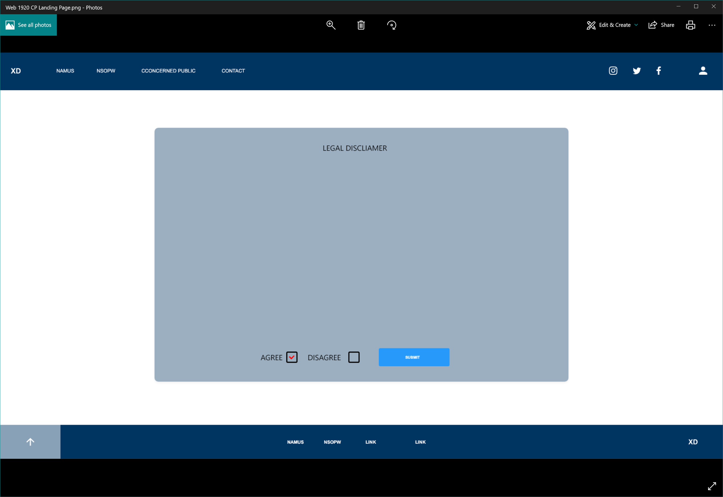

Disclaimer Agreement

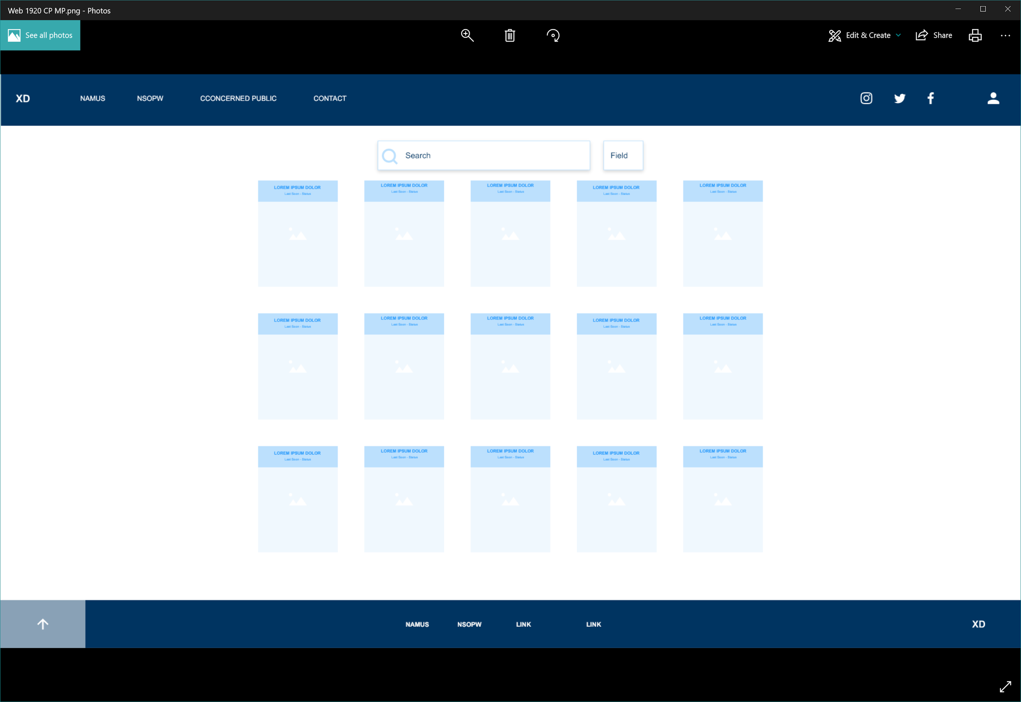

Landing Page

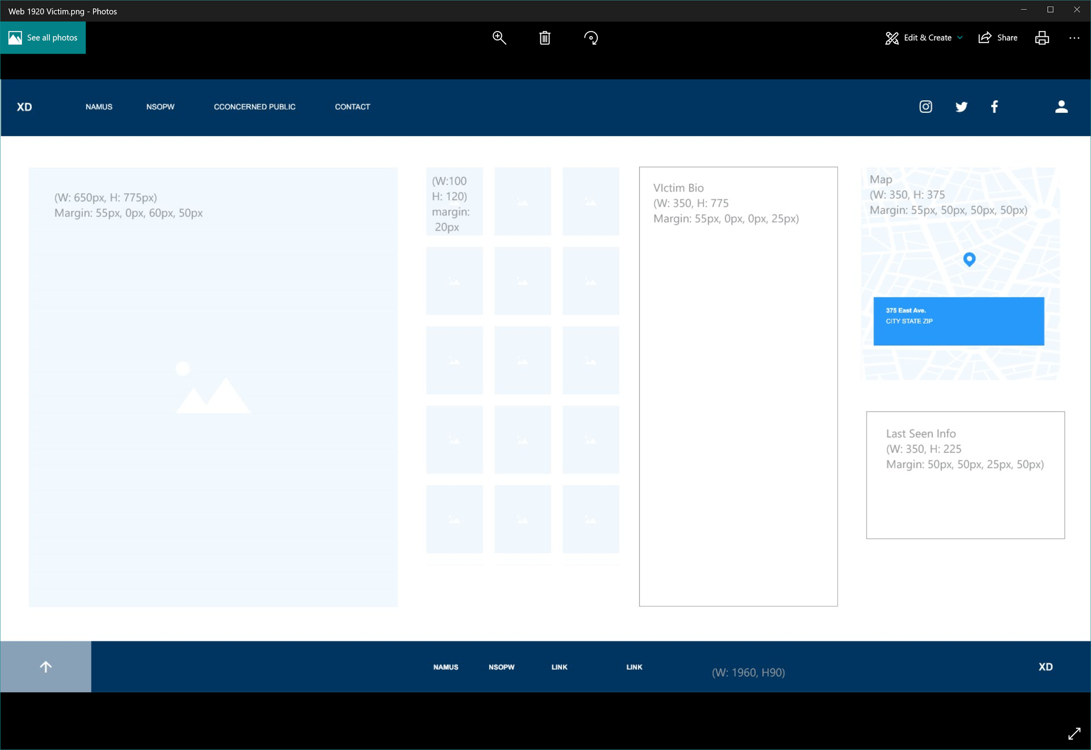

##### Forms

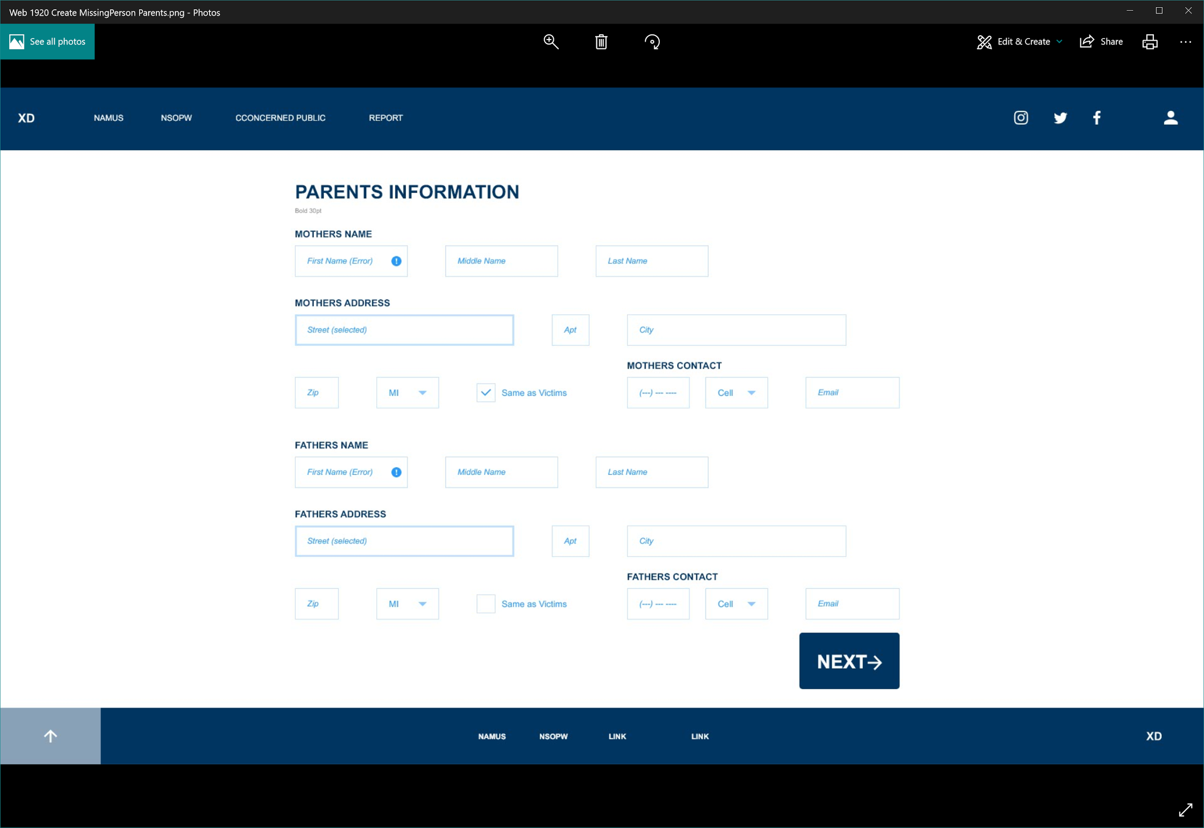

Parents Information Form

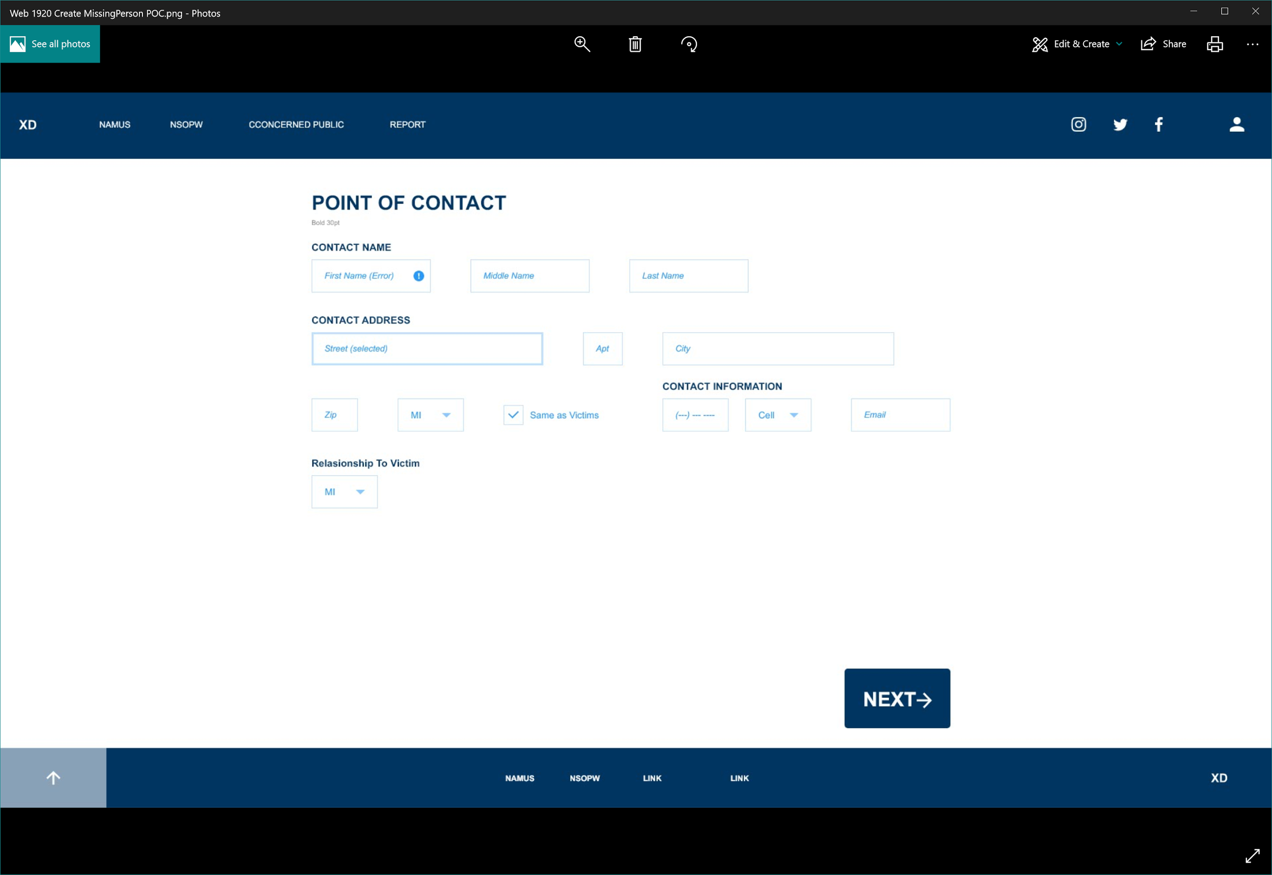

Point of contact Form

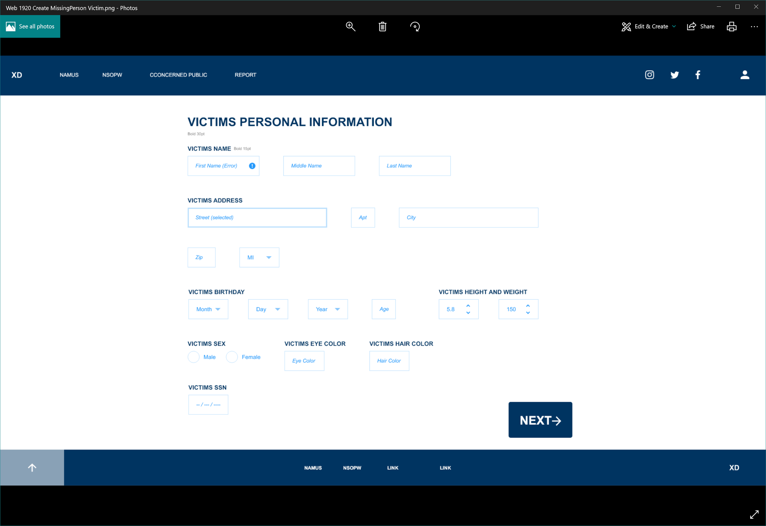

Victims personal Information Form

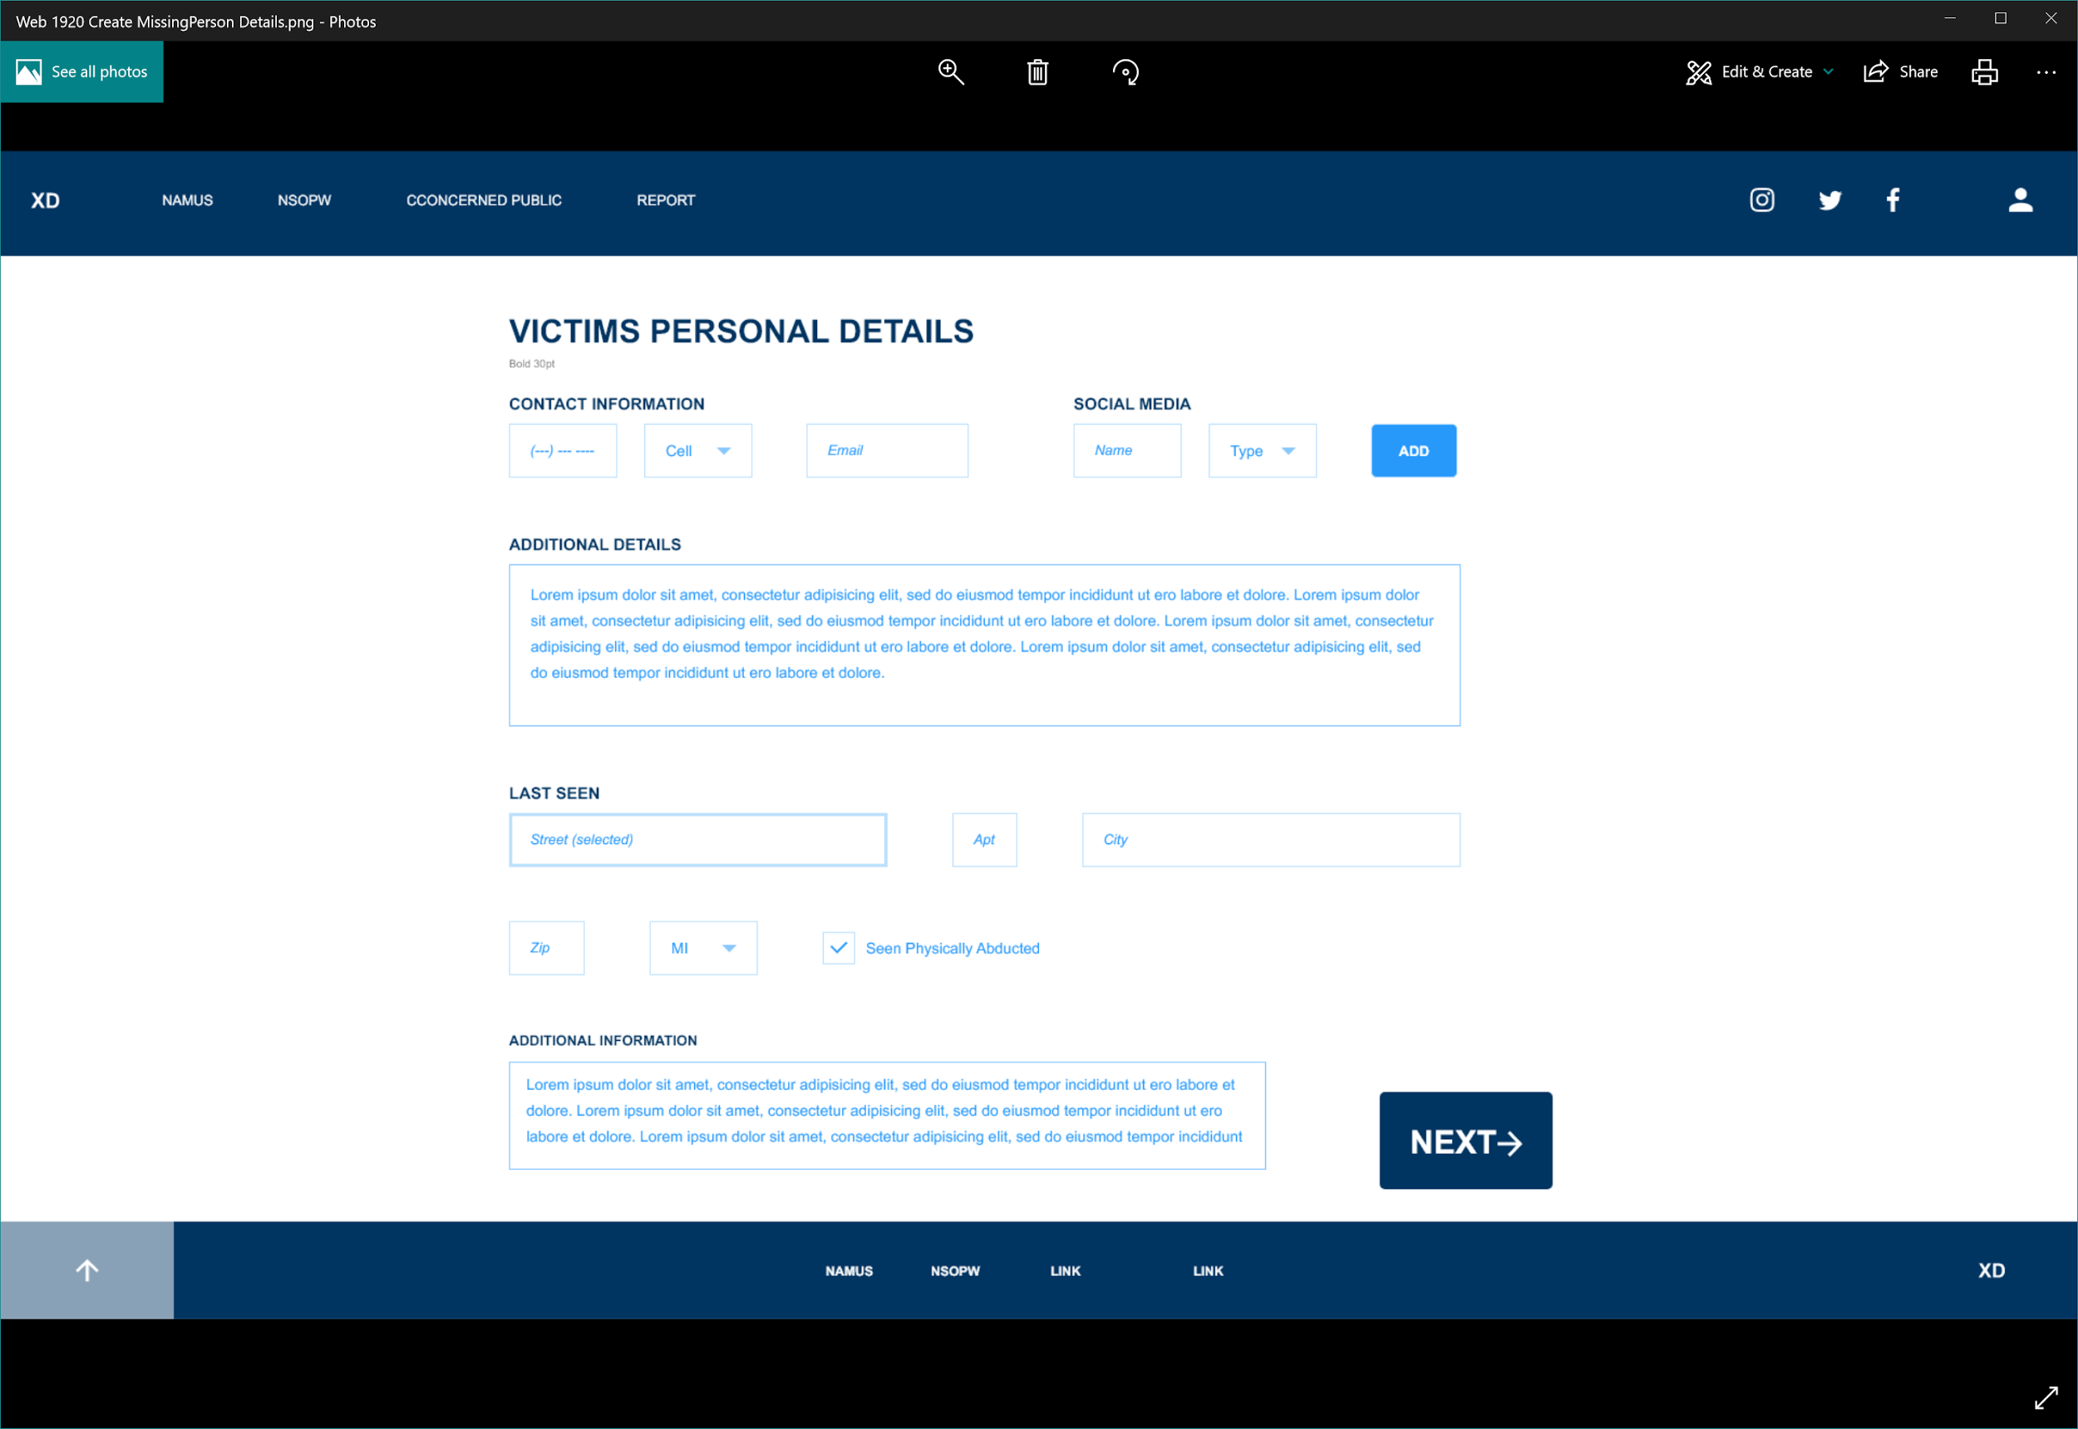

Victim Personal Details Form

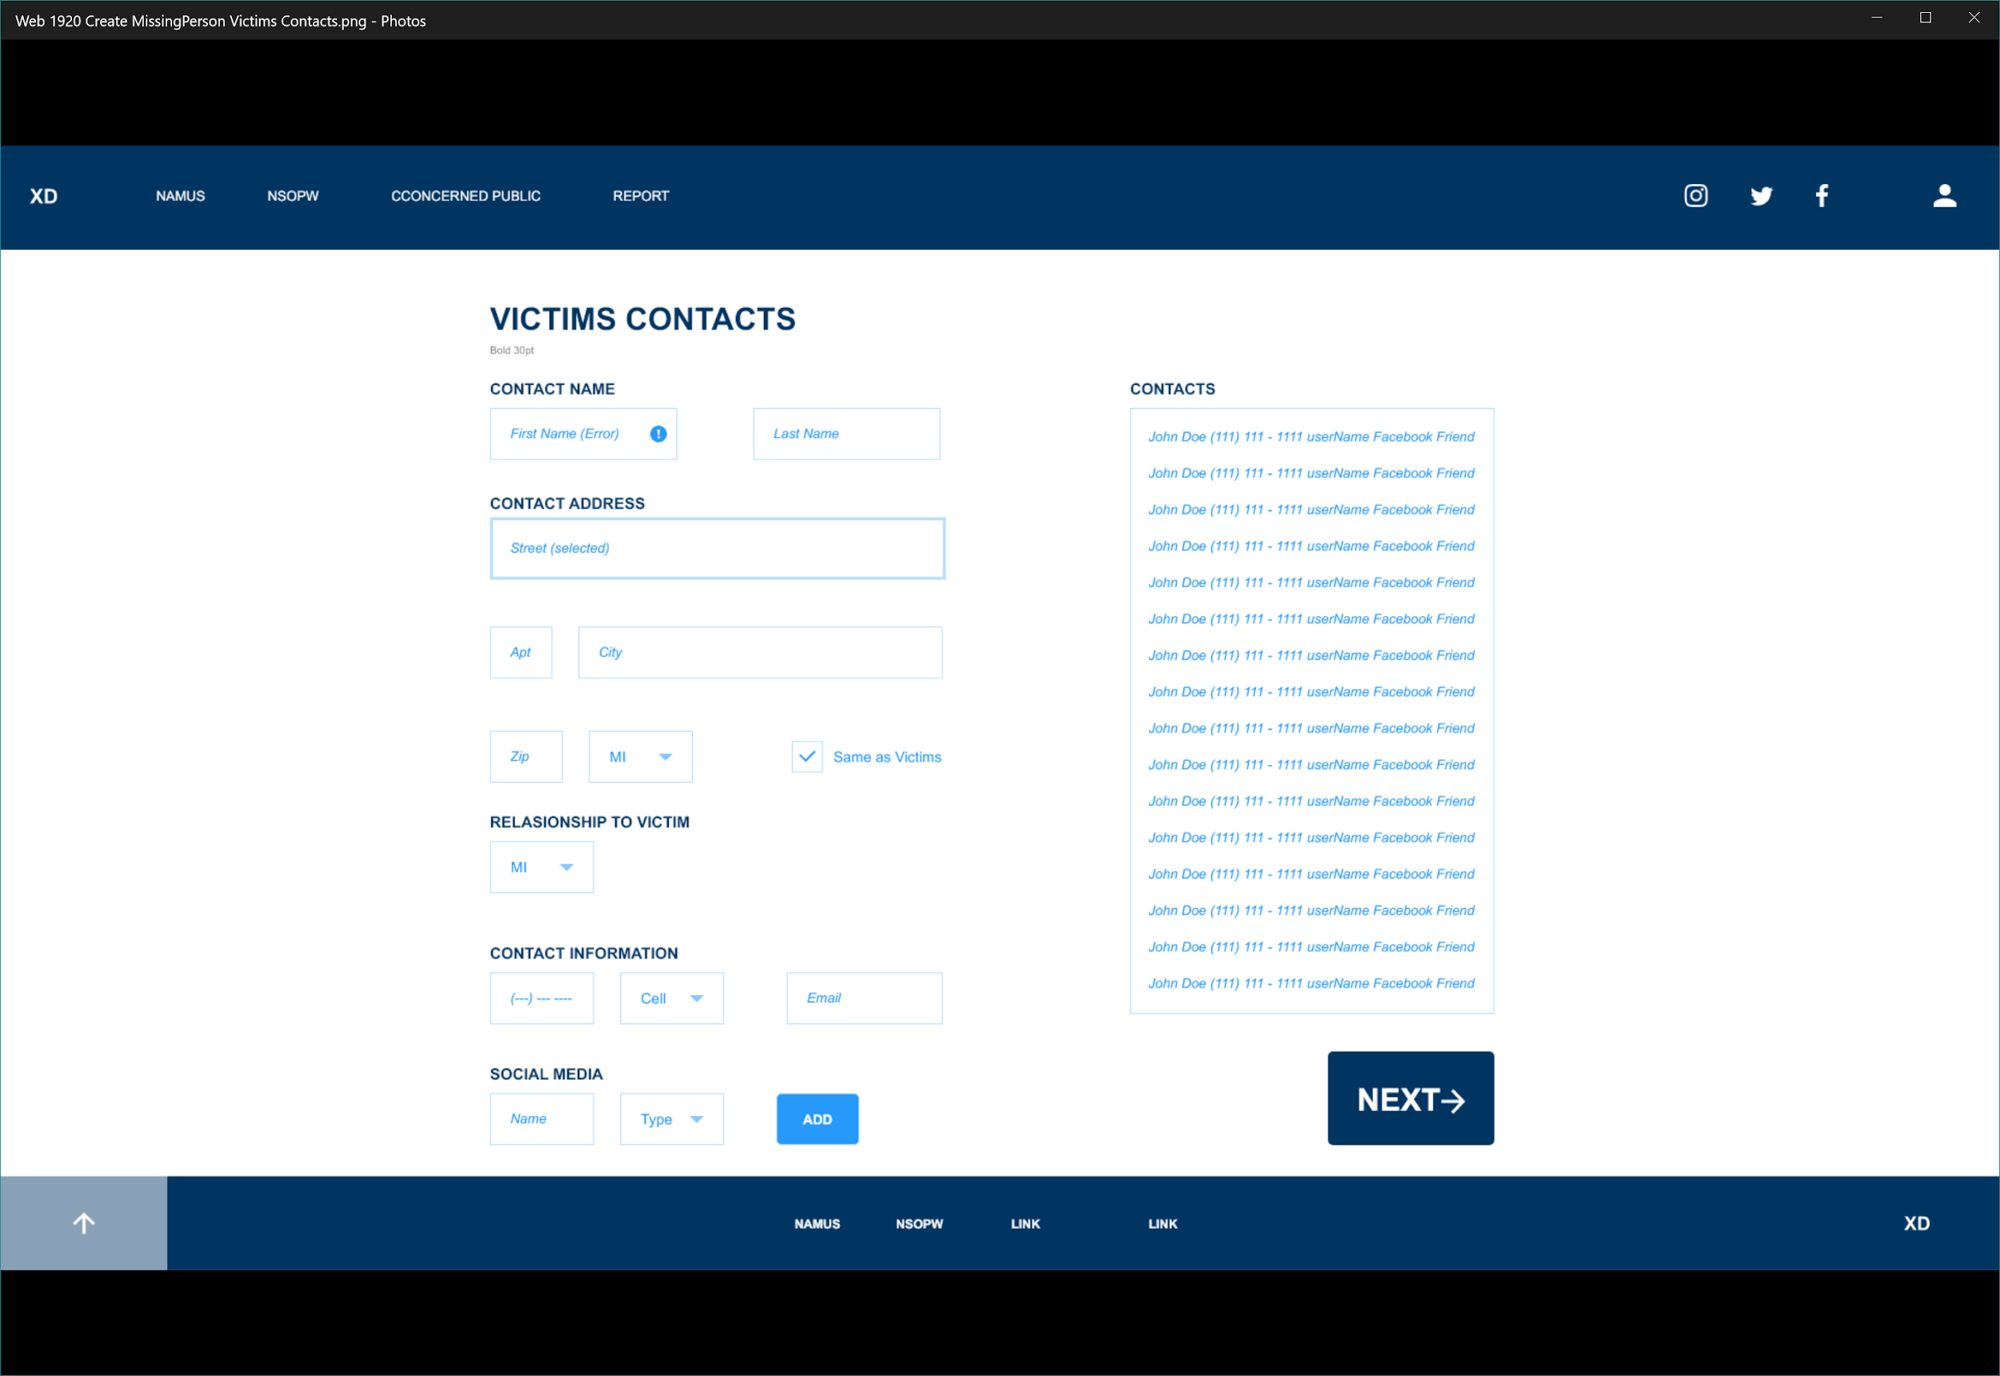

Victims contacts Form

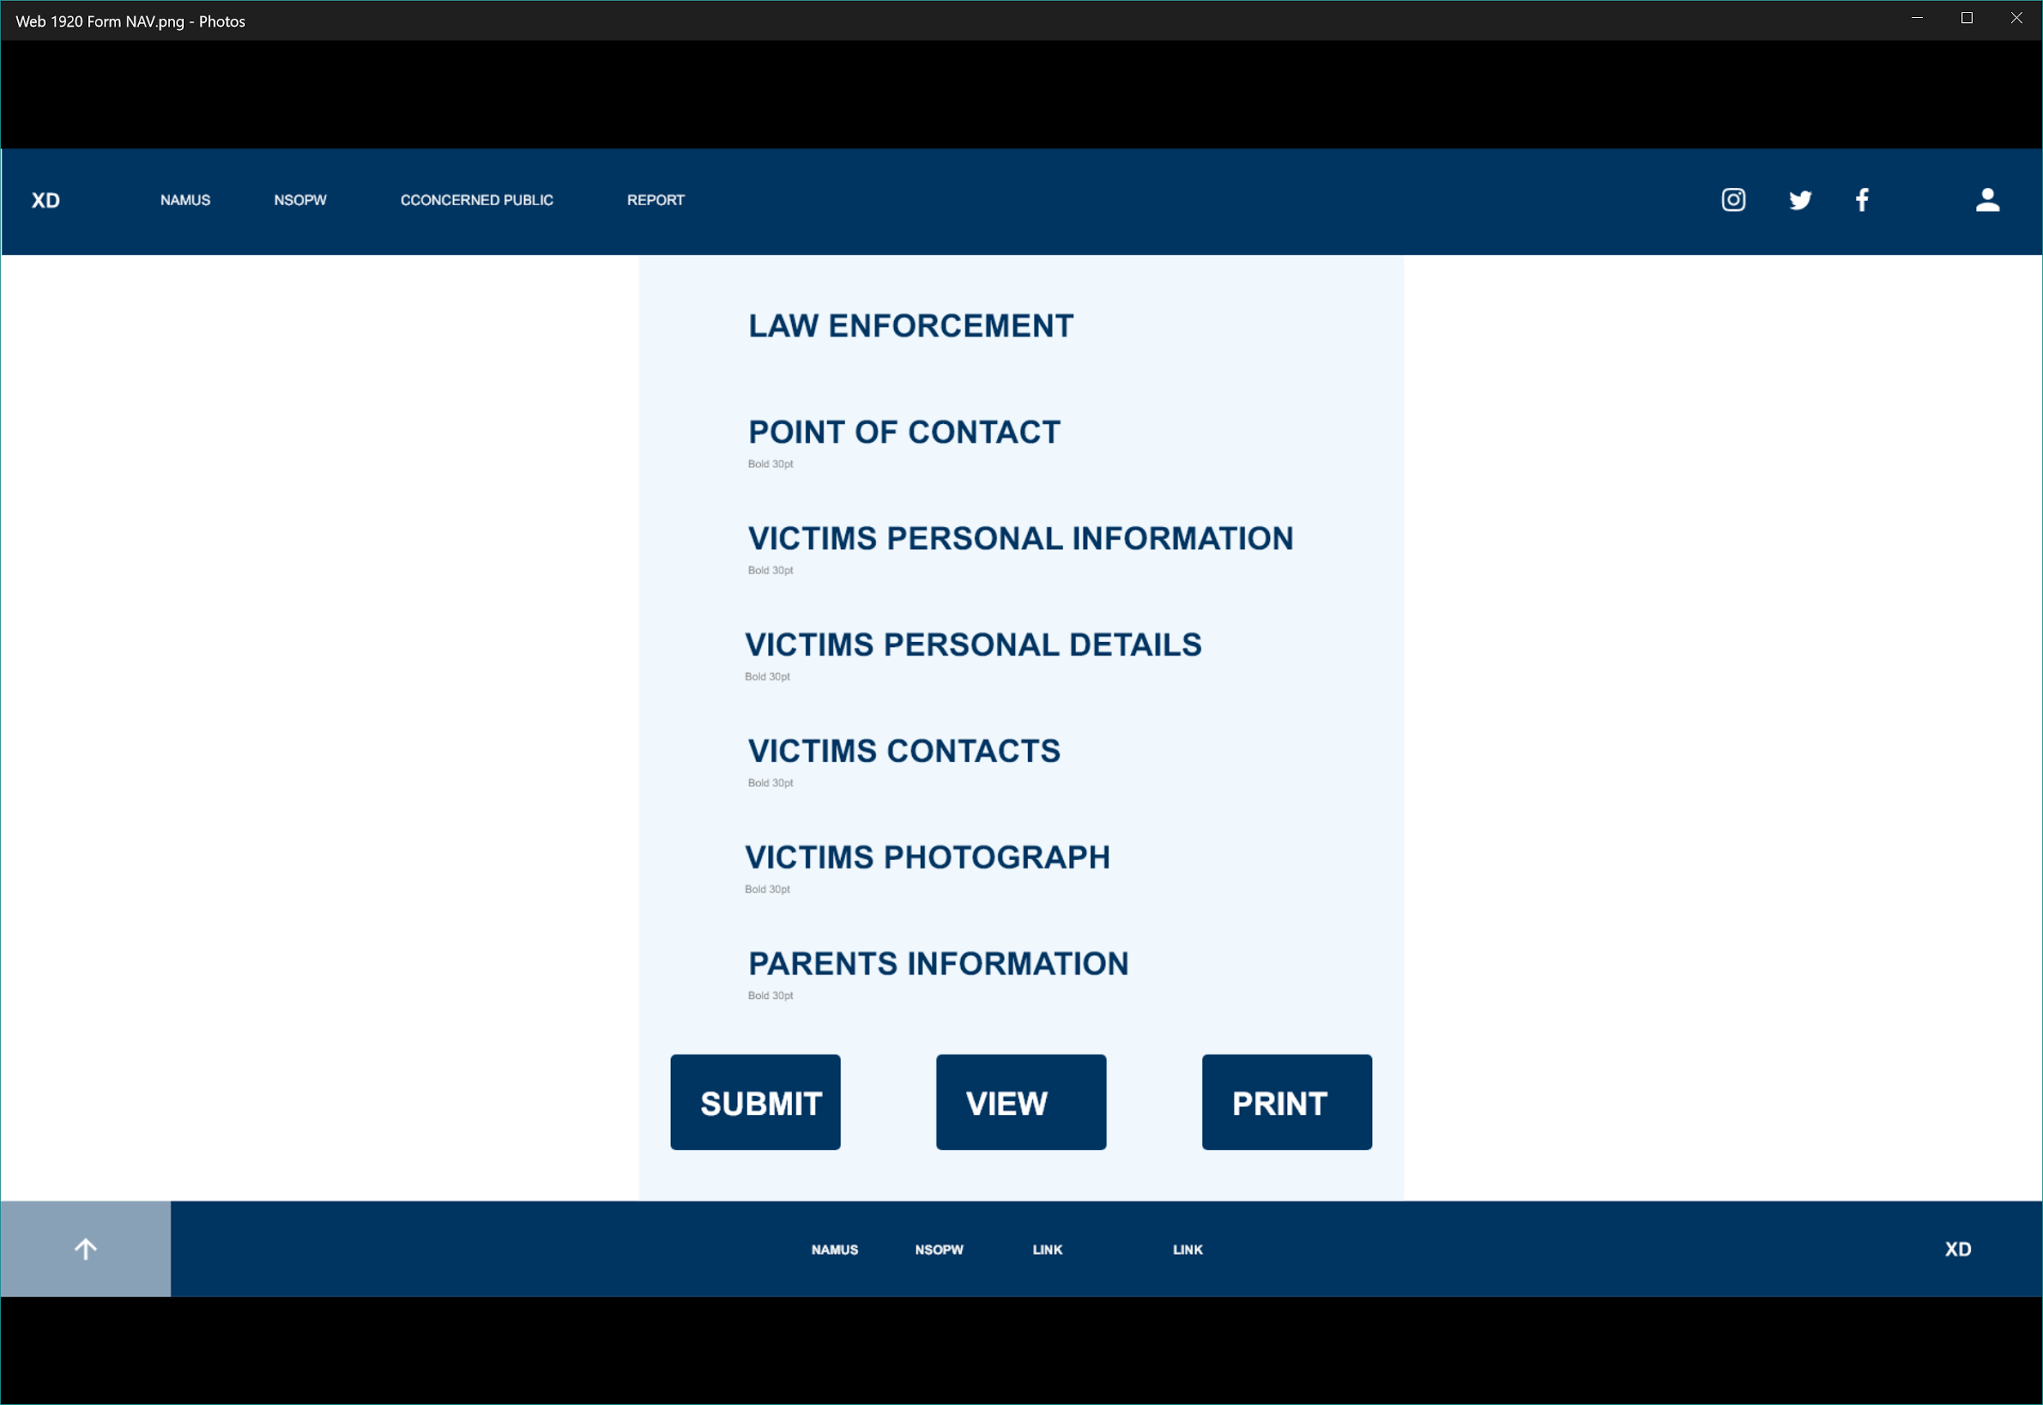

Navigation Page

##### LogIn

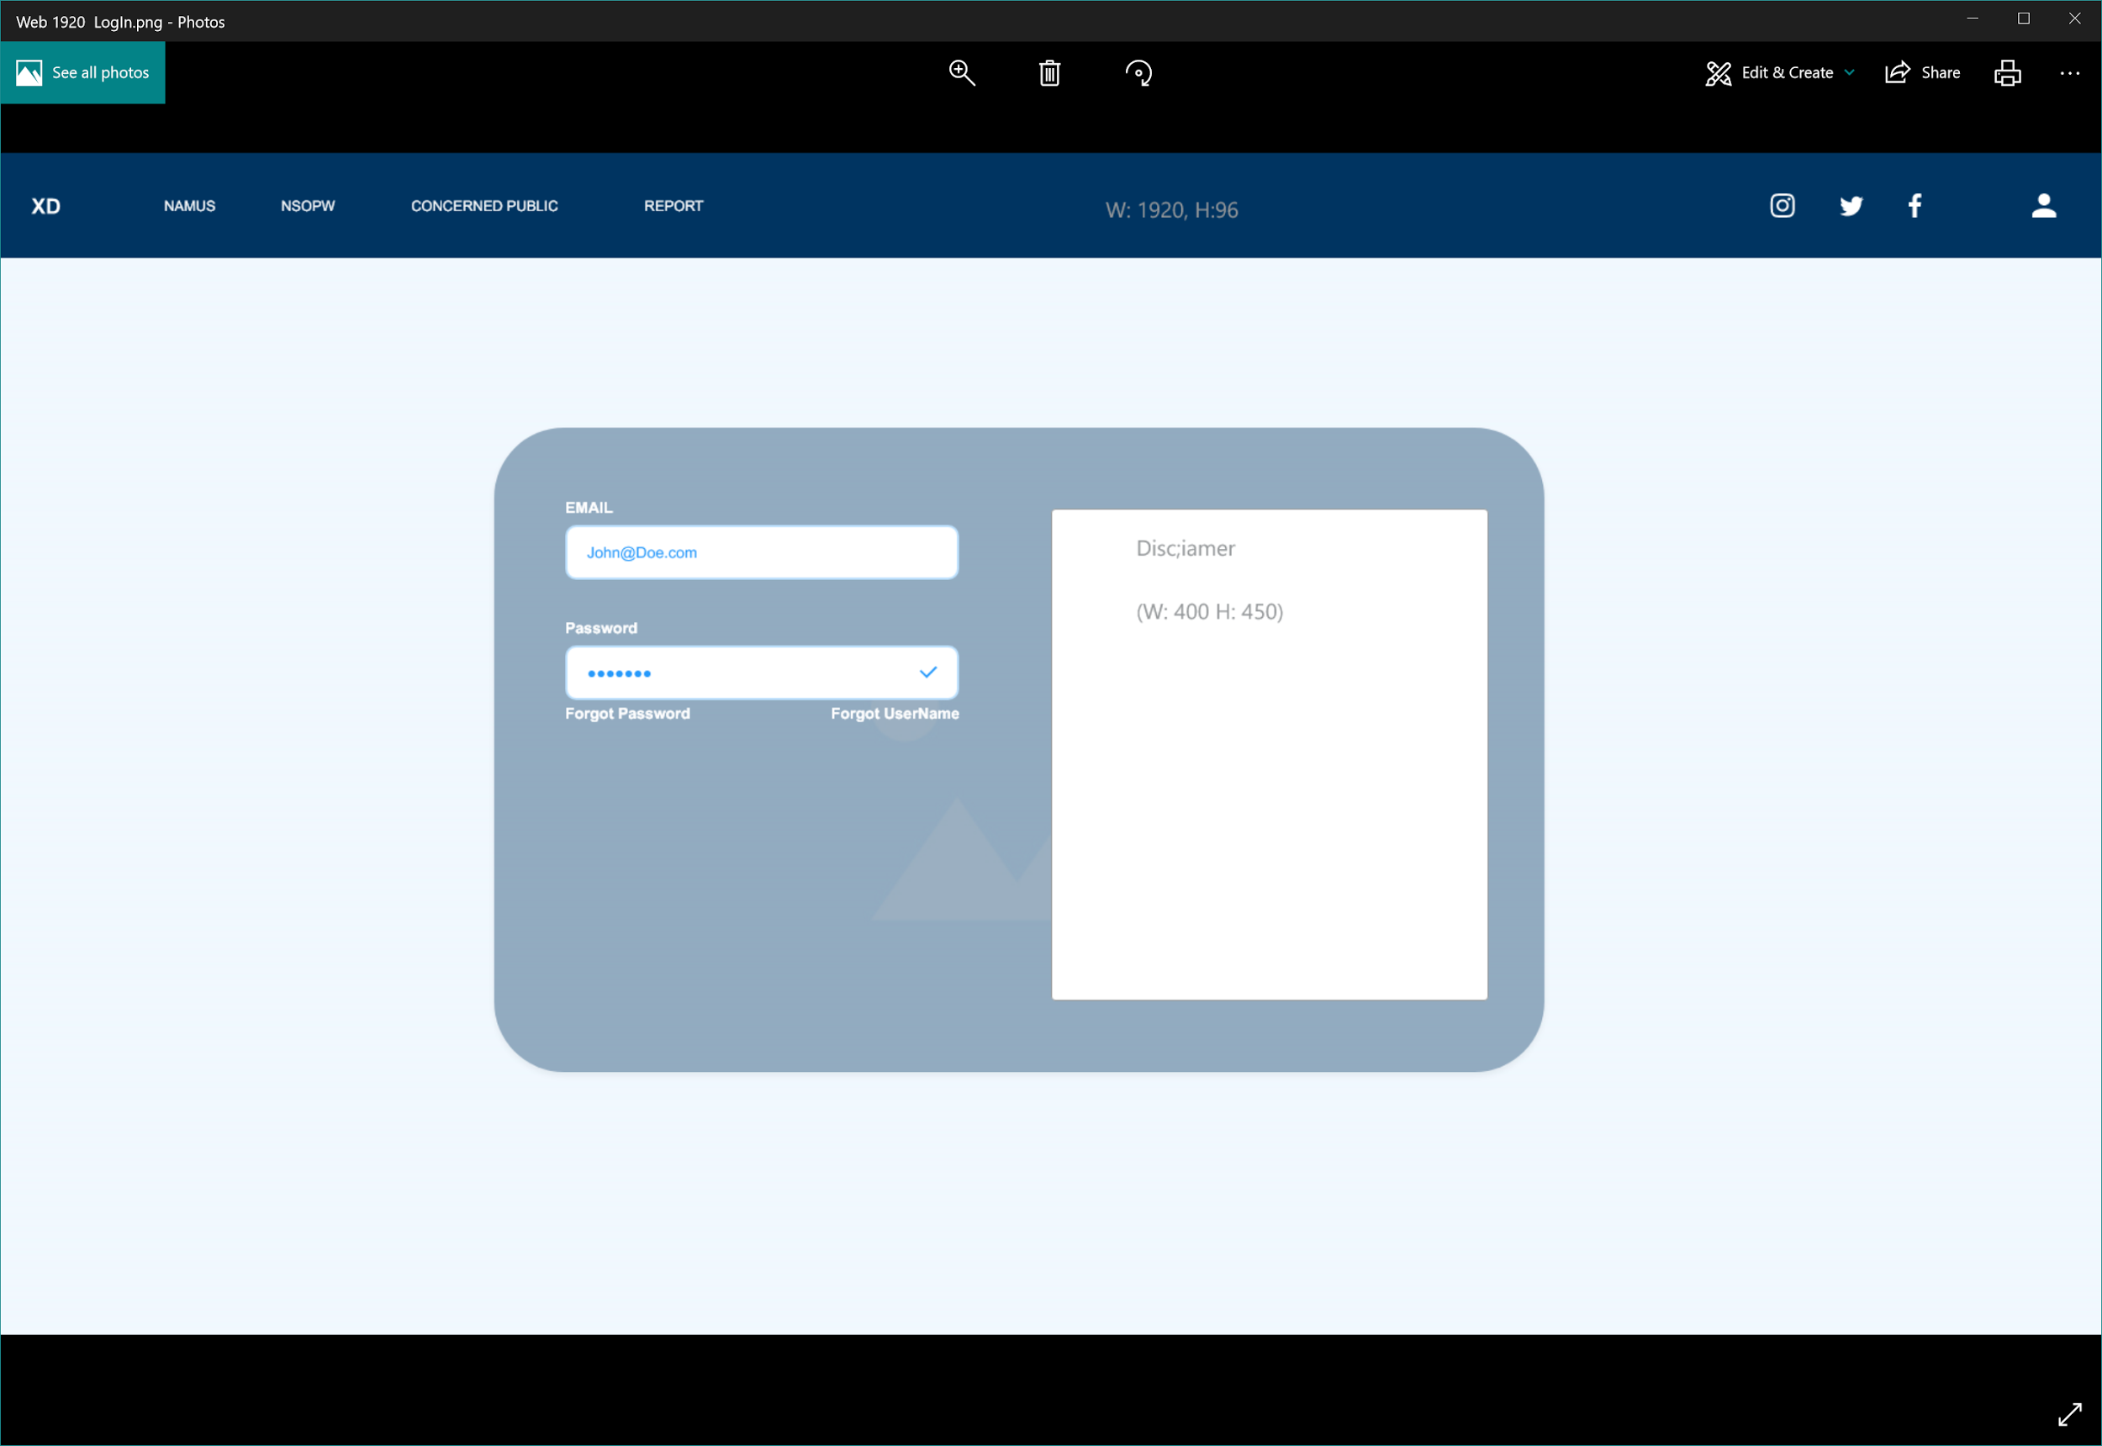

LogIn page

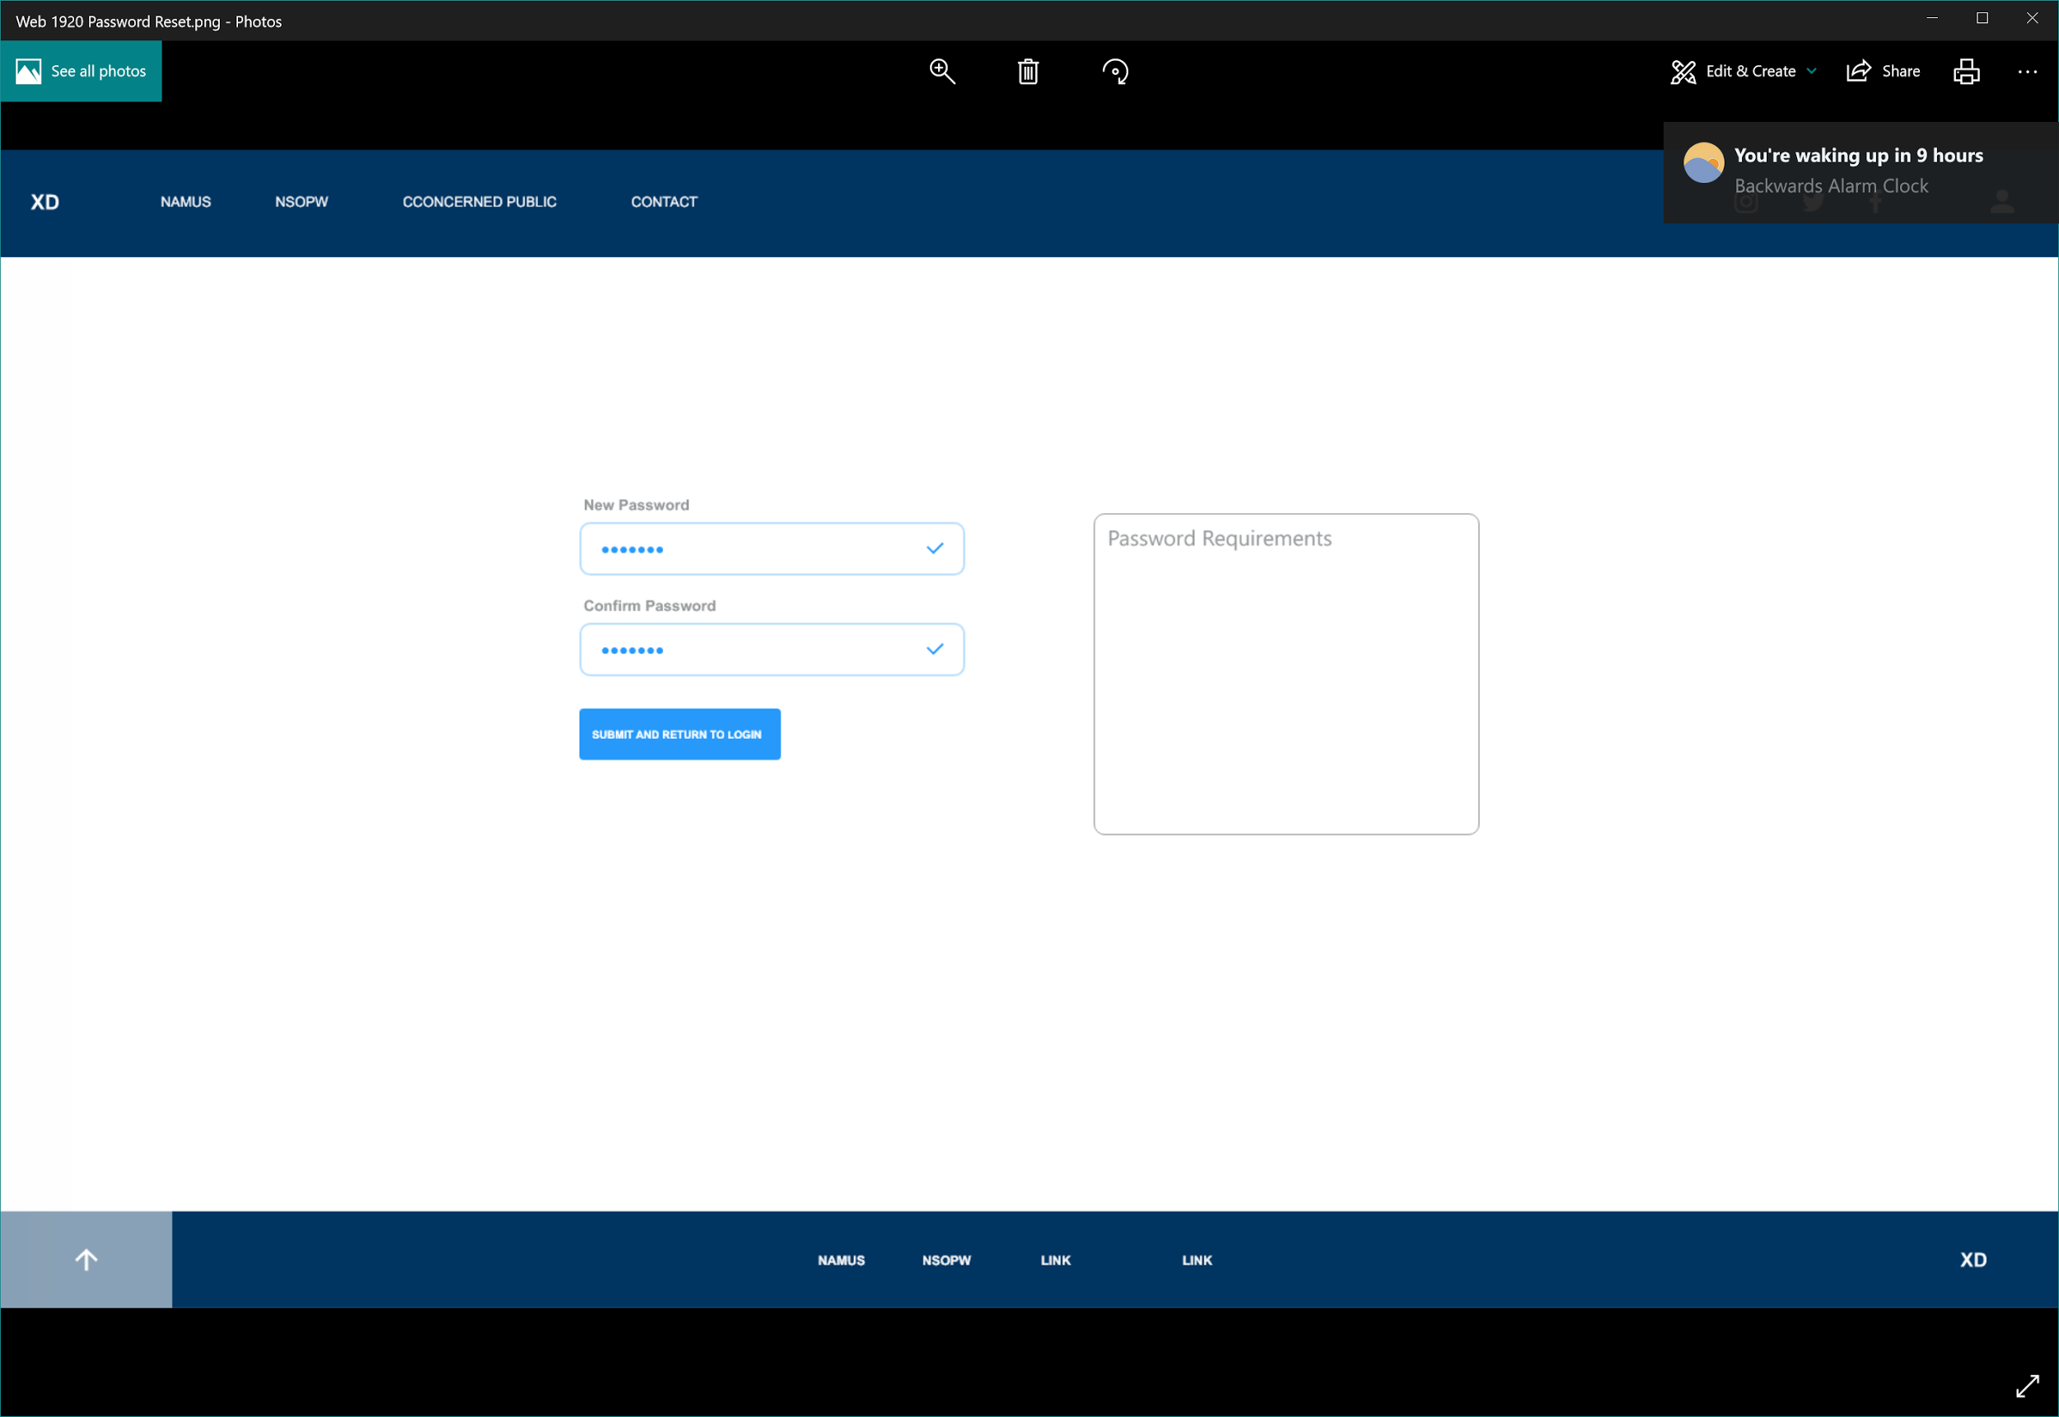

Password Reset

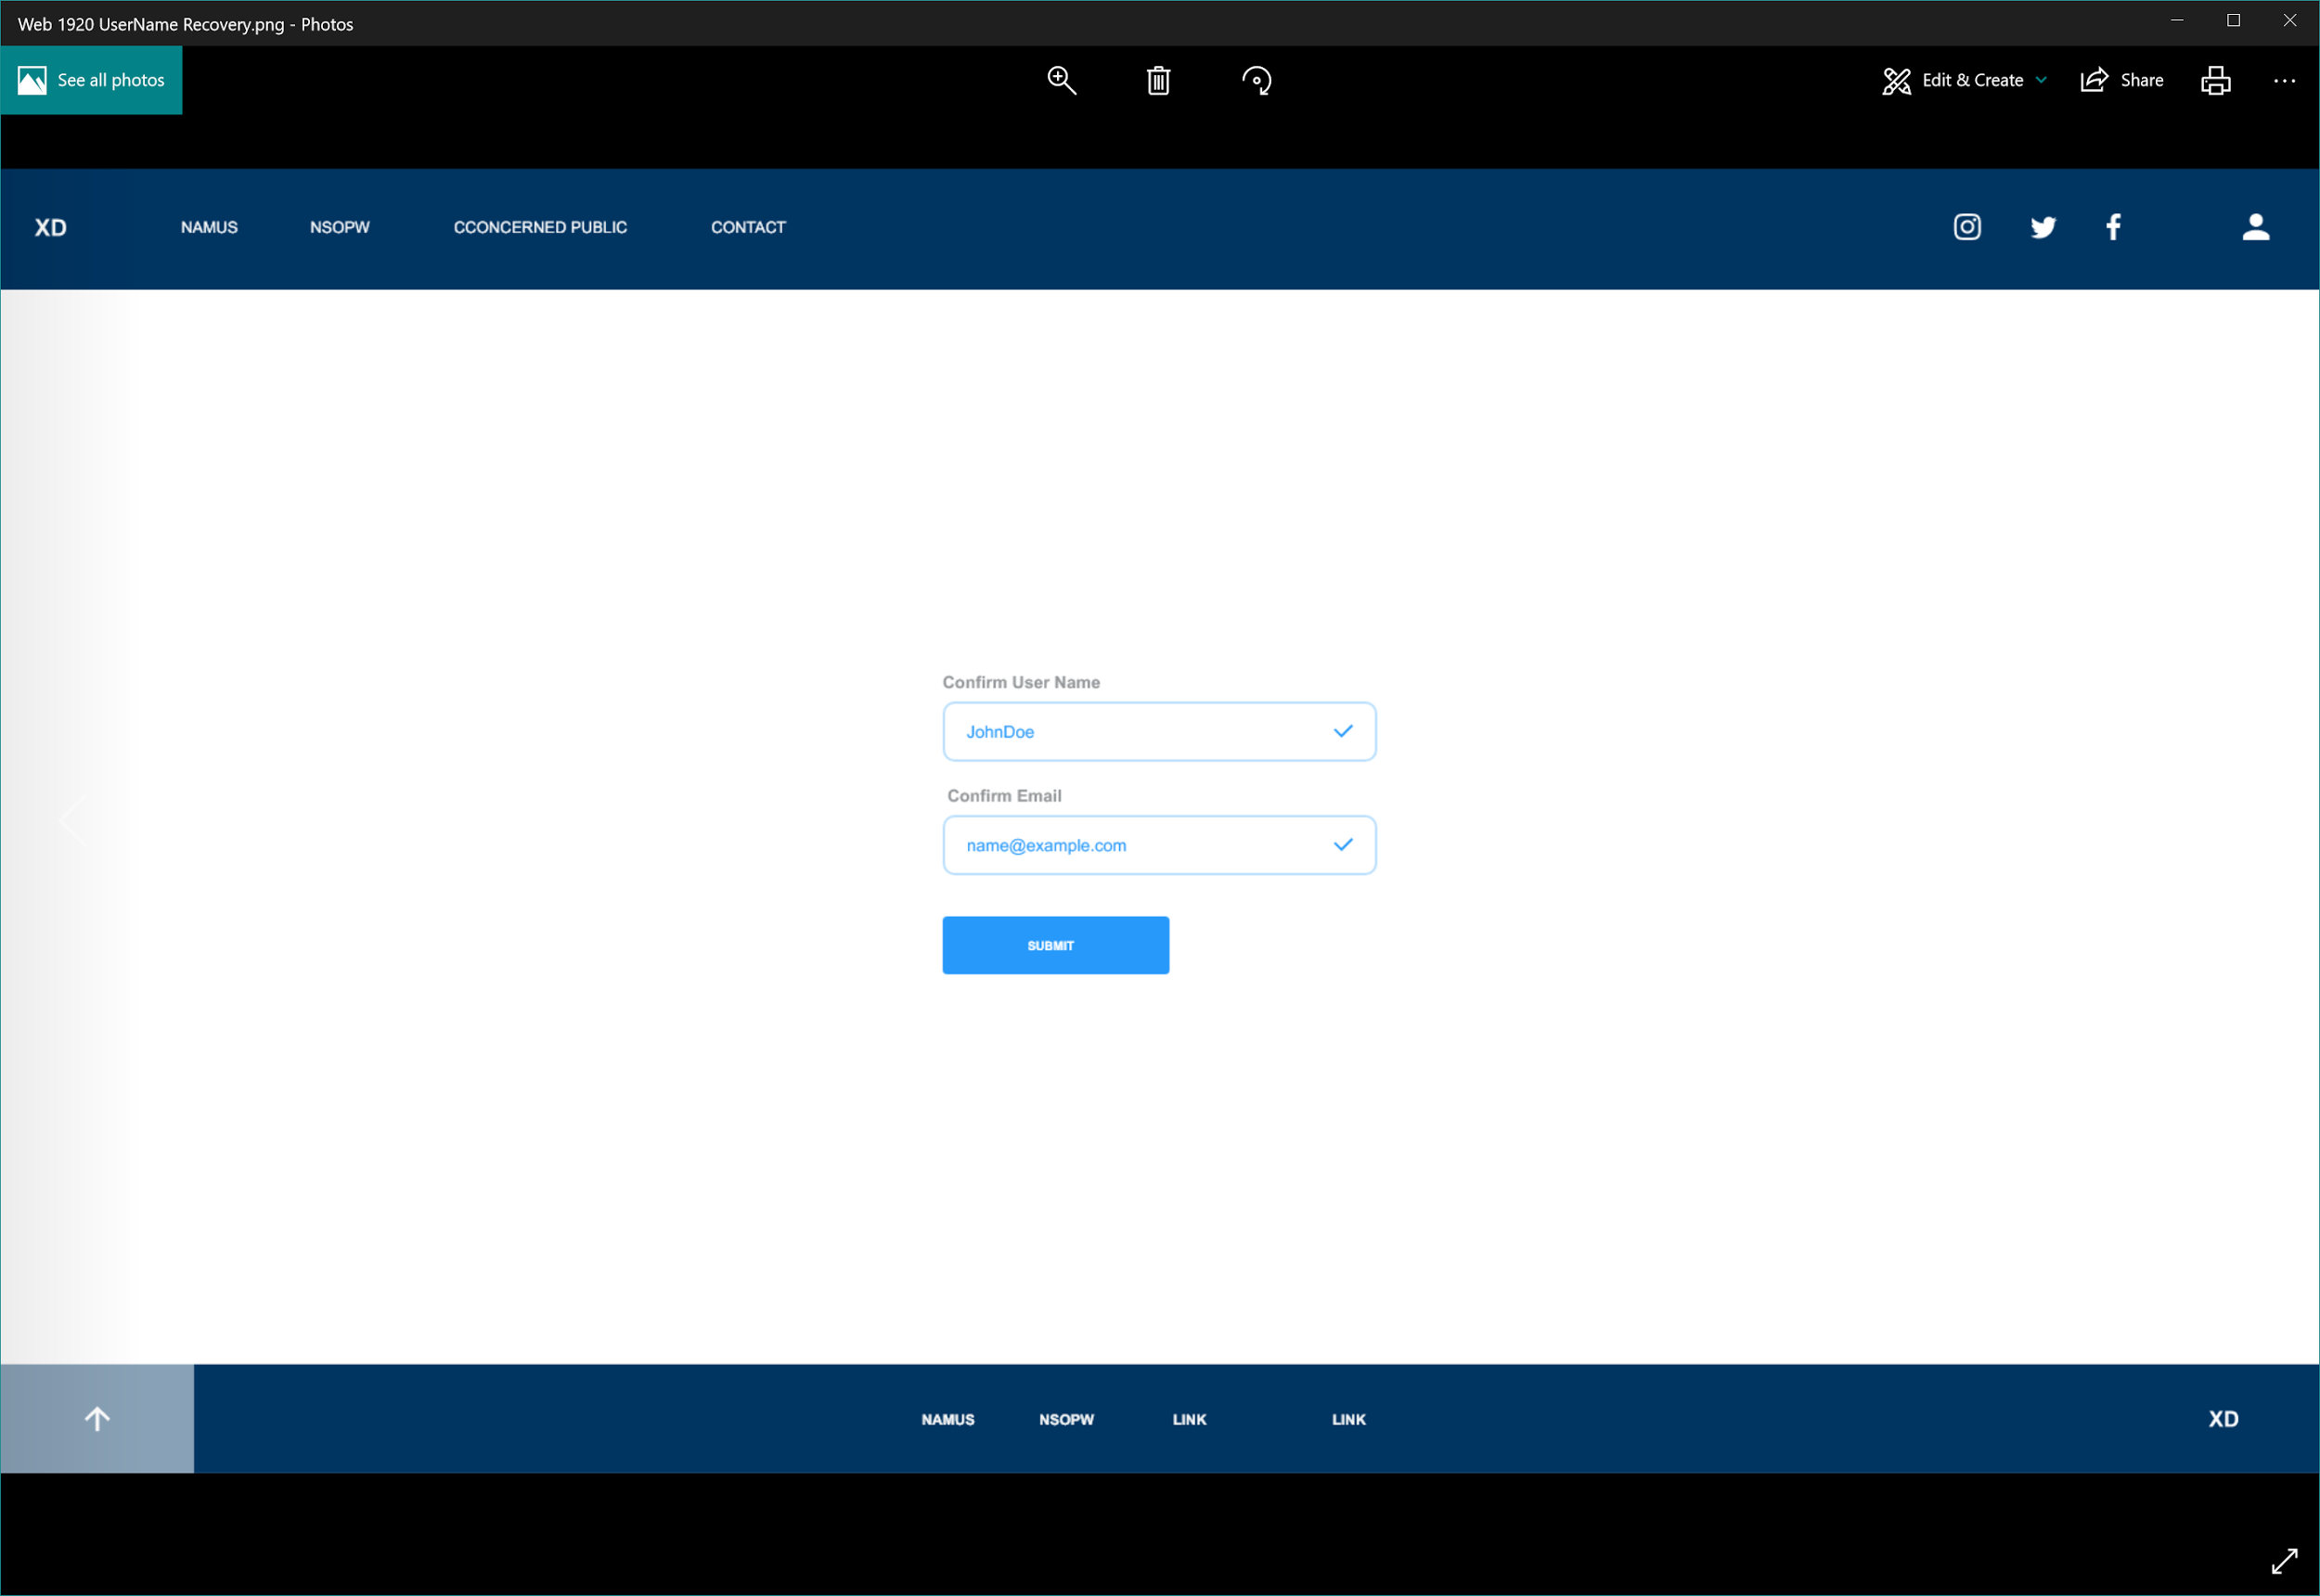

UserName Recovery

## 4. Functional Requirements Specification

#### 4.1. Stakeholders

The stakeholders of the MIM System Software are primarily the parents and family members of the missing person and law enforcement.

* Families: The largest stakeholders of the MIM System Software are families who will have the advantage of online digital tools to help locate their missing loved ones. By investing in the MIM System Software, families will be able to take charge in sharing pertinent information between them and law enforcement and help expedite the process of finding the missing person.
* Law Enforcement: The second stakeholder of the MIM System Software is law enforcement who will use the system to obtain notifications from families and concerned public using the MIM System to report missing individuals. Law Enforcements is challenged to maintain organization when a person is missing. By investing in the MIM System Software, law enforcement will be able to control the process and workflow to locate a missing person.

#### 4.2. Actors and Goals

* Parents: Mother and Father of the missing person. Their goal is to report information of their missing child and use the MIM system to enter pertinent information describing their child, such as height, weight, demographics, DOB, and photographs.
* Law Enforcement: Police Officers searching for the missing person. Their goal is to receive email notifications from parents, friends, and the concerned public reporting on the missing person.
* Friends: Close friends of the families of the missing person. Their goal is to be identified for investigatory purposes to reduce those involved.
* Concerned Public: Any member of the public that sees or has information about the missing person that they can report and make available for the investigation process. Their goal is to report any information they find regarding a location of the missing person and upload an image of the suspected missing person.

#### 4.3. User stories, scenarios and Use Cases

#### 4.4. System Sequence / Activity Diagrams

## 5. User Interface Specifications

#### 5.1. Preliminary Design

#### 5.2. User Effort Estimation

## 6. Static Design

#### 6.1. Class Model

#### 6.2. System Operation Contracts

#### 6.3. Mathematical Model

#### 6.4. Entity Relation

## 7. Dynamic Design

#### 7.1. Sequence Diagrams.

#### 7.2. Interface Specification

#### 7.3. State Diagrams

## 8. System Architecture and System Design

#### 8.1. Subsystems / Component / Design Pattern Identification

#### 8.2. Mapping Subsystems to Hardware (Deployment Diagram)

#### 8.3. Persistent Data Storage

#### 8.4. Network Protocol

#### 8.5. Global Control Flow

#### 8.6. Hardware Requirement

## 9. Algorithms and Data Structures

#### 9.1. Algorithms

#### 9.2. Data Structures

## 10. User Interface Design and Implementation

#### 10.1. User Interface Design

#### 10.2. User Interface Implementation

## 11. Testing

#### 11.1. Unit Test Architecture and Strategy/Framework

#### 11.2. Unit test definition, test data selection

#### 11.3. System Test Specification

#### 11.4. Test Reports per Spring

## 12. Project Management

#### 12.1. 11.1 Project Plan

#### 12.2. 11.2 Risk management

## 13. References

[1] Telephone Records and Privacy Protection Act of 2006, Pub. L. No. 109-476, 120 STAT. 3568 (2006).